Employee_Attendance_System

Abstract
The Employee Attendance System is a comprehensive and integrated software solution sdesigned to efficiently manage employee-related data and operations within an organization. This system automates the tracking of employee attendance, leave management, timesheet recording, payroll processing, and reporting, thereby reducing administrative overhead and increasing accuracy. The primary entities involved in this system include:
- Employee: This entity stores detailed information about each employee, including personal details, contact information, job position, department, and salary.
- Attendance Record: This entity logs daily attendance details, tracking employee check-in and check-out times to monitor punctuality and working hours.
- Leave: This entity manages employee leave requests and approvals, maintaining records of various leave types such as sick leave, vacation, and personal leave.
- Timesheet: This entity captures the hours worked by employees on different tasks or projects, enabling detailed tracking of labor distribution and project time allocation.
- Payroll: This entity handles the computation and processing of employee salaries, incorporating attendance records, leave, overtime, and deductions to generate accurate payroll reports.
- Schedule: This entity manages employee work schedules, ensuring proper allocation of shifts and resources to meet organizational needs.
- Department: This entity organizes employees into different departments, facilitating departmental management and reporting.
- Shift: This entity defines various work shifts, assigning employees to appropriate shifts based on their schedules and organizational requirements.
- Overtime: This entity tracks and manages overtime work, ensuring that employees are compensated appropriately for extra hours worked beyond their regular schedule.
- Report: This entity generates various reports related to attendance, leave, payroll, and other employee-related data, providing insights and supporting decision-making processes.
The system offers a user-friendly interface and robust backend support, ensuring seamless integration and scalability to accommodate the growing needs of an organization. By automating and centralizing employee attendance and related operations, the Employee Attendance System enhances operational efficiency, promotes transparency, and improves overall workforce management.

Introduction
The Employee Attendance System project aims to create a comprehensive software solution designed to efficiently manage various aspects of employee administration within an organization. This system provides a robust framework for tracking employee attendance, managing leave requests, recording timesheets, processing payroll, scheduling shifts, and generating detailed reports.
- Employee Management: Central to the system is the Employee entity, which stores essential information about each staff member, including personal details, contact information, job title, department, salary, and date of birth.
- Attendance Tracking: The system logs daily attendance, capturing check-in and check-out times to monitor employee punctuality and working hours.
- Leave Management: Employees can submit leave requests, which are then processed and approved by managers.
- Timesheet Recording: Detailed timesheets are recorded for employees, documenting the hours worked on different tasks or projects.
- Payroll Processing: Integrating attendance, leave, and overtime data, the system calculates employee salaries accurately.
- Scheduling and Shift Management: The system facilitates the creation and management .
- Overtime Tracking: The system tracks overtime work to ensure employees are compensated correctly for additional hours worked.
- Departmental Organization: Employees are organized into departments within the system, allowing for effective departmental management and reporting.
- Reporting: Comprehensive reporting capabilities enable the generation of detailed reports on attendance, leave, payroll, and other employee metrics.
- Efficiency: Automates repetitive administrative tasks, saving time and reducing the potential for human error.
- Accuracy: Ensures precise tracking and management of employee-related data, improving the reliability of attendance and payroll processes.
- Transparency: Enhances visibility into employee activities and organizational operations, fostering a culture of accountability and openness.
- Scalability: Designed to accommodate the growing needs of an organization, supporting an expanding workforce and increasing complexity of operations.
- Compliance: Helps organizations adhere to labor laws and internal policies, minimizing the risk of legal issues and promoting fair labor practices.
- SQL QUERIES OF EMPLOYEE ATTENDENCE SYSTEM
- #CREATE DATABASE EMPTAD1
- create database empatd1;
- #USE DATABASE EMPTAD1
- use empatd1;
- #Create table employees
- CREATE TABLE employees (
- eid INT PRIMARY KEY,
- first_name VARCHAR(50),
- last_name VARCHAR(50),
- position VARCHAR(100),
- dept_id INT,
- salary DECIMAL(10, 2),
- DOB DATE
- );
- select * from employees;
- #Create table Attendance_Record
- create table Attendance_Record(
- record_id int primary key,
- eid int,
- foreign key(eid) references employees(eid),
- working_date date,
- in_Time timestamp,
- out_Time timestamp
- );
- select * from Attendance_Record;
- #Create table Department
- create table Department(
- dept_id int primary key,
- dept_name varchar(200) not null
- );
- select * from Department;
- #Create table Leaves
- create table Leaves(
- leave_id int primary key not null,
- eid int,
- foreign key(eid) references employees(eid),
- leave_type varchar(255) not null,
- start_date date,
- end_date date
- );
- select * from Leaves;
- #Create table payroll
- create table payroll(
- payroll_id int primary key,
- eid int,
- foreign key(eid) references employees(eid),
- PayPeriodStartDate date not null,
- PayPeriodEndDate date not null,
- Grosspay bigint,
- taxes int
- );
- select * from payroll;
- #create table Timesheet
- create table Timesheet(
- Timesheet_id bigint primary key,
- eid int,
- foreign key(eid) references employees(eid),
- WeekStartDate date not null,
- WeekEndDate date not null,
- TotalHours timestamp
- );
- select * from Timesheet;
- # Create table Shift
- create table Shift(
- shift_id bigint primary key,
- Starttime time,
- Endtime time,
- shift_description varchar(290),
- overtime timestamp
- );
- select * from Shift;
- #Create Table Schedules
- CREATE TABLE Schedules (
- schedule_id BIGINT PRIMARY KEY,
- dept_id INT,
- FOREIGN KEY (dept_id) REFERENCES Department(dept_id),
- shift_id BIGINT,
- FOREIGN KEY (shift_id) REFERENCES Shift(shift_id),
- WeekStartDate DATE,
- WeekEndDate DATE
- );
- # create table records
- create table records(
- record_id bigint primary key,
- dept_id int,
- foreign key(dept_id) references Department(dept_id),
- eid int,
- foreign key(eid) references employees(eid),
- report_name varchar(290),
- report_description varchar(290),
- ReportDate date);
- select * from records;
- #Adding column eid to Department
- ALTER TABLE Department
- ADD COLUMN eid INT,
- ADD CONSTRAINT fk_employee_department
- FOREIGN KEY (eid) REFERENCES employees(eid);
- select * from Department;
- # create table Overtime
- create table Overtime(
- OvertimeID BIGINT primary key,
- shift_id bigint,
- foreign key(shift_id) references Shift(shift_id),
- eid int,
- foreign key(eid) references employees(eid),
- OvertimeDate date,
- OvertimeHours time
- );
- select * from Overtime;
- Inserting 50 records in the tables
- # Insert 50 records into the table employees
- INSERT INTO employees (eid, first_name, last_name, position, dept_id, salary, DOB) VALUES
- (1, 'John', 'Doe', 'Manager', 101, 75000.00, '1980-01-15'),
- (2, 'Jane', 'Smith', 'Developer', 102, 68000.00, '1985-02-20'),
- (3, 'Alice', 'Johnson', 'Analyst', 103, 62000.00, '1990-03-25'),
- (4, 'Bob', 'Williams', 'Designer', 104, 59000.00, '1983-04-30'),
- (5, 'Charlie', 'Brown', 'Support', 105, 50000.00, '1992-05-10'),
- (6, 'David', 'Jones', 'HR', 101, 70000.00, '1984-06-15'),
- (7, 'Eva', 'Garcia', 'Developer', 102, 67000.00, '1989-07-20'),
- (8, 'Frank', 'Martinez', 'Analyst', 103, 61000.00, '1982-08-25'),
- (9, 'Grace', 'Rodriguez', 'Designer', 104, 58000.00, '1991-09-30'),
- (10, 'Hank', 'Lewis', 'Support', 105, 51000.00, '1987-10-05'),
- (11, 'Ivy', 'Walker', 'Manager', 101, 76000.00, '1979-11-10'),
- (12, 'Jack', 'Hall', 'Developer', 102, 69000.00, '1986-12-15'),
- (13, 'Kara', 'Allen', 'Analyst', 103, 63000.00, '1993-01-20'),
- (14, 'Liam', 'Young', 'Designer', 104, 60000.00, '1988-02-25'),
- (15, 'Mia', 'Hernandez', 'Support', 105, 52000.00, '1981-03-30'),
- (16, 'Noah', 'King', 'HR', 101, 71000.00, '1985-04-05'),
- (17, 'Olivia', 'Scott', 'Developer', 102, 68000.00, '1990-05-10'),
- (18, 'Paul', 'Green', 'Analyst', 103, 62000.00, '1983-06-15'),
- (19, 'Quinn', 'Adams', 'Designer', 104, 59000.00, '1992-07-20'),
- (20, 'Ryan', 'Baker', 'Support', 105, 53000.00, '1984-08-25'),
- (21, 'Sara', 'Gonzalez', 'Manager', 101, 77000.00, '1987-09-30'),
- (22, 'Tom', 'Nelson', 'Developer', 102, 70000.00, '1988-10-05'),
- (23, 'Uma', 'Carter', 'Analyst', 103, 64000.00, '1991-11-10'),
- (24, 'Vince', 'Mitchell', 'Designer', 104, 60000.00, '1989-12-15'),
- (25, 'Wendy', 'Perez', 'Support', 105, 54000.00, '1982-01-20'),
- (26, 'Xander', 'Roberts', 'HR', 101, 72000.00, '1986-02-25'),
- (27, 'Yara', 'Turner', 'Developer', 102, 69000.00, '1994-03-30'),
- (28, 'Zack', 'Phillips', 'Analyst', 103, 65000.00, '1981-04-05'),
- (29, 'Amy', 'Campbell', 'Designer', 104, 61000.00, '1983-05-10'),
- (30, 'Ben', 'Parker', 'Support', 105, 55000.00, '1985-06-15'),
- (31, 'Cara', 'Evans', 'Manager', 101, 78000.00, '1987-07-20'),
- (32, 'Dan', 'Edwards', 'Developer', 102, 71000.00, '1990-08-25'),
- (33, 'Ella', 'Collins', 'Analyst', 103, 66000.00, '1988-09-30'),
- (34, 'Finn', 'Stewart', 'Designer', 104, 62000.00, '1984-10-05'),
- (35, 'Gina', 'Sanchez', 'Support', 105, 56000.00, '1989-11-10'),
- (36, 'Hugo', 'Morris', 'HR', 101, 73000.00, '1985-12-15'),
- (37, 'Iris', 'Rogers', 'Developer', 102, 72000.00, '1981-01-20'),
- (38, 'Jake', 'Reed', 'Analyst', 103, 67000.00, '1990-02-25'),
- (39, 'Kyla', 'Cook', 'Designer', 104, 63000.00, '1987-03-30'),
- (40, 'Leo', 'Morgan', 'Support', 105, 57000.00, '1984-04-05'),
- (41, 'Maya', 'Bell', 'Manager', 101, 79000.00, '1988-05-10'),
- (42, 'Nina', 'Murphy', 'Developer', 102, 73000.00, '1986-06-15'),
- (43, 'Owen', 'Bailey', 'Analyst', 103, 68000.00, '1989-07-20'),
- (44, 'Pia', 'Rivera', 'Designer', 104, 64000.00, '1982-08-25'),
- (45, 'Quincy', 'Hayes', 'Support', 105, 58000.00, '1985-09-30'),
- (46, 'Rita', 'Griffin', 'HR', 101, 74000.00, '1990-10-05'),
- (47, 'Sam', 'Russell', 'Developer', 102, 74000.00, '1988-11-10'),
- (48, 'Tina', 'Ortiz', 'Analyst', 103, 69000.00, '1991-12-15'),
- (49, 'Ulysses', 'Bennett', 'Designer', 104, 65000.00, '1983-01-20'),
- (50, 'Vera', 'Jenkins', 'Support', 105, 59000.00, '1987-02-25');

- select * from employees;

UML DIAGRAM:

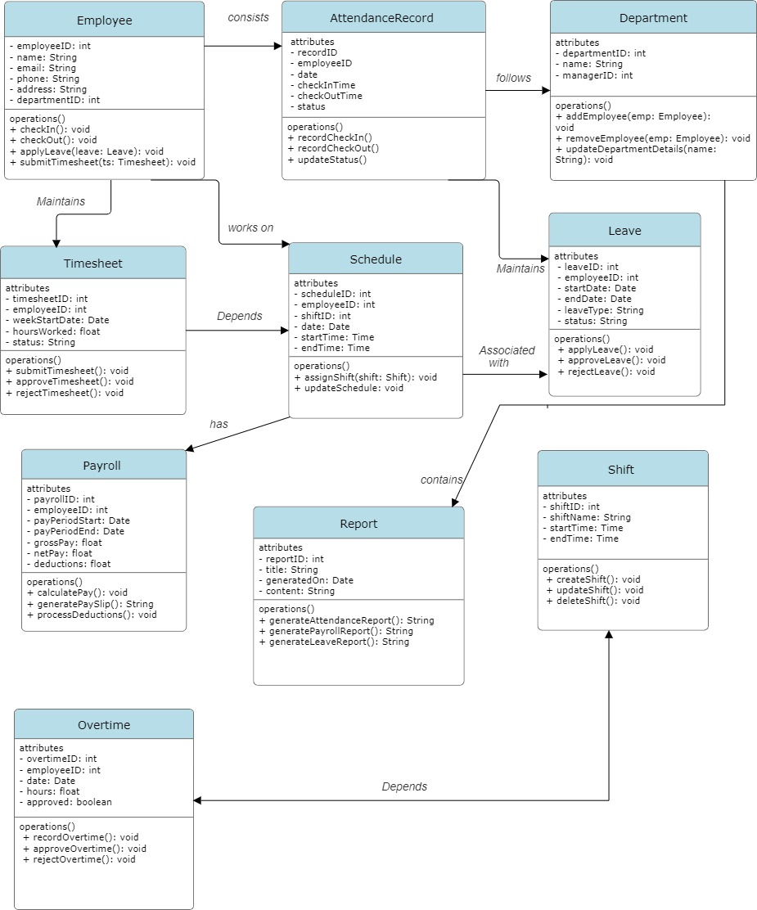

Functional Requirements of Employee Attendance System

1. User Management
- User Authentication: Secure login and logout for employees, managers, and admins using unique credentials.
- Role Management: Assign roles such as Employee, Manager, and Admin with specific permissions for each role.
- Profile Management: Ability for users to view and update their profile information.

2. Attendance Recording
- Clock In/Out: Employees can clock in and clock out via the system.
- Manual Adjustments: Authorized personnel can manually adjust attendance records when necessary.
- Location Tracking: Option to capture the geographical location during clock in/out to ensure compliance with location-based policies.

3. Attendance Monitoring

- Daily Attendance View: Managers and admins can view attendance for the current day.
- Monthly Attendance View: Access to monthly attendance summaries for all employees.
- Real-Time Status: Real-time display of which employees are currently clocked in.

4. Leave Management

- Leave Application: Employees can submit leave requests through the system.
- Leave Approval Workflow: Managers can approve or deny leave requests.
- Leave Balance Inquiry: Employees can check their remaining leave balance.

5. Notifications and Alerts

- Automated Reminders: Send reminders to employees to clock in/out.
- Leave Status Alerts: Notify employees of the status of their leave applications (approved/denied).
- Absence Alerts: Alert managers when employees fail to clock in within a specified time frame.

6. Reporting and Analytics

- Attendance Reports: Generate detailed reports on daily, weekly, and monthly attendance.
- Leave Reports: Create reports detailing leave taken by employees over specified periods.
- Custom Reports: Ability to generate customized reports based on various parameters.

7. Integration Capabilities

- Payroll Integration: Connect with payroll systems to ensure accurate wage calculations based on attendance data.
- HR System Integration: Sync employee data with existing HR systems to maintain consistency.

8. Data Management

- Data Export: Export attendance and leave data in multiple formats such as CSV and Excel.
- Data Import: Import employee and attendance data from other systems or spreadsheets.

Audit and Compliance

- Activity Logging: Keep detailed logs of all user actions for auditing purposes.
- Audit Trails: Generate audit reports to review attendance and leave records.

User Interface

- Dashboard: Provide an intuitive dashboard for different user roles with relevant information and shortcuts.
- Mobile Access: Ensure the system is mobile-friendly or provide a dedicated mobile app for ease of access.

Summary
The Employee Attendance System should streamline attendance and leave management, offering real-time tracking, comprehensive reporting, and seamless integration with other business systems. These functional and non-functional requirements ensure the system is efficient, secure, and user-friendly, thereby enhancing overall organizational productivity.

Project Report: Employee Attendance System

Table of Contents
- Executive Summary
- Introduction
- Project Objectives
- Scope of Work
- System Design
- Functional Requirements
- Non-Functional Requirements
- System Architecture
- Implementation
- Testing and Quality Assurance
- Deployment
- User Training and Documentation
- Maintenance and Support
- Conclusion
- Appendices

1. Executive Summary
The Employee Attendance System project aims to automate attendance tracking, leave management, and related processes to improve efficiency and accuracy within the organization. This comprehensive report details the project's objectives, scope, design, requirements, implementation, testing, deployment, and ongoing maintenance.

2. Introduction
In today's fast-paced work environment, accurate tracking of employee attendance is crucial for business operations. Manual attendance recording methods are prone to errors and inefficiencies. Therefore, the implementation of a digital Employee Attendance System is essential to streamline processes and ensure compliance with labor regulations.

3. Project Objectives
The primary objectives of the Employee Attendance System project are:
- Automate attendance tracking and leave management processes.
- Improve accuracy and reliability of attendance records.
- Enhance reporting capabilities for better decision-making.
- Ensure compliance with labor laws and regulations.
- Provide a user-friendly interface for all stakeholders.

4. Scope of Work
The scope of the project includes:
- Development of a web-based application for attendance management.
- Integration with existing systems such as payroll and HR.
- Implementation of features including leave management, scheduling, and overtime tracking.
- Training and documentation for end-users.
- Ongoing maintenance and support.
5. System Design
The system is designed using a modular approach, consisting of several interconnected entities:
- Employee
- Attendance Record
- Leave
- Timesheet
- Payroll
- Schedule
- Department
- Shift
- Overtime
- Report
Each entity plays a crucial role in managing different aspects of employee attendance and related processes.

6. Functional Requirements
The functional requirements of the Employee Attendance System include:
- Employee management: Add, update, and delete employee records.
- Attendance recording: Capture clock-in/out times and manage manual adjustments.
- Leave management: Handle leave applications, approvals, and balance tracking.
- Timesheet management: Track hours worked and calculate overtime.
- Payroll integration: Sync attendance data with payroll for accurate wage calculation.
- Schedule management: Assign shifts and manage employee schedules.
- Department management: Categorize employees into departments for organizational purposes.
- Report generation: Generate various reports including attendance, leave, and overtime reports.

7. Non-Functional Requirements
Key non-functional requirements include:
- Performance: Ensure the system performs efficiently under load.
- Scalability: Design the system to accommodate a growing number of users and data.
- Security: Implement robust security measures to protect sensitive employee data.
- Usability: Develop an intuitive user interface for easy navigation and usage.
- Reliability: Ensure high availability and minimal downtime of the system.
- Compliance: Adhere to relevant labor laws and regulations.

8. System Architecture
The system architecture follows a multi-tiered approach, comprising presentation, application logic, and data layers. Each layer is designed to handle specific functionalities, ensuring modularity and scalability.

9. Implementation
During the implementation phase, the system was developed according to the design specifications. Key tasks included database design, coding, integration with third-party systems, and user interface development.

10. Testing and Quality Assurance
Comprehensive testing was conducted to ensure the functionality, performance, and reliability of the system. Testing methodologies included unit testing, integration testing, system testing, and user acceptance testing.

11. Deployment
The system was deployed in a phased manner, starting with a pilot rollout followed by full deployment. Data migration, user training, and post-deployment support were integral parts of the deployment process.

12. User Training and Documentation
Training sessions were conducted for end-users to familiarize them with the system's features and functionalities. Detailed documentation was provided for reference purposes.

13. Maintenance and Support
Ongoing maintenance and support services are provided to ensure the system remains operational and up-to-date. Regular updates, bug fixes, and user support are part of the maintenance plan.

14. Conclusion
The Employee Attendance System project has successfully delivered a robust and efficient solution for attendance management within the organization. By automating processes and improving accuracy, the system contributes to enhanced productivity and compliance.

15. Appendices
Relevant appendices include:
- Entity relationship diagrams
- System architecture diagrams
- Test plans and results
- User manuals and documentation
CHALLENGES LIST:
- Understanding normalization and relationships.
- Designing effective schemas and ER diagrams.
- Writing complex SQL queries.
- Using DBMS tools and handling errors.
- Applying theoretical knowledge practically.

Top of Form

